**Ohio Lions**

**Eye Research Foundation Inc.**

**Gratefully acknowledges**

**For supporting research into the causes of blindness for the year**

**Research Centers supported:**

**Case Western Reserve University, Department of** **Ophthalmology**

**The Ohio State University, Schools of Optometry and Ophthalmology**

**University of Cincinnati, Department of Ophthalmology**

**Wright State University, Department of Bio-Chemistry and Molecular Biology**

**Nationwide Children’s Hospital (Columbus), Department of Ophthalmology**

**Akron Children’s Hospital, Department of Ophthalmology**

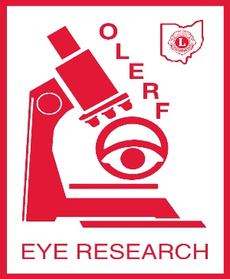**Northeastern Ohio Medical School**

**Executive Director: Lydia Houser**

**President: Nancy Brown**

**Trustee:**